Getting Started

Learning Objectives
This is Part 2 of the Intro to NVivo workshop. We will build on the grocery store project using additional data types, and explore using queries.

Scenario and Data Overview
You have been hired to investigate what customers are saying about the grocery store, in order to allocate some funding money into improving the store.

You have received additional qualitative data to help answer your research question. They include results from a survey, and a focus group, with some overlap in respondents.

- Download the following to your computer:
  - cleaned-Grocery-store
  - focus_group_transcript

Log in to VPN - Working Off-Campus
In order for NVIVO to work correctly with any institutional shared drives (ie: OneDrive) you may be required to log in to a VPN. https://uoguelphca.sharepoint.com/sites/ccs/SitePages/anyconnect-vpn-user-guide.aspx

Review the project so far:
Our project currently has the following elements created in Part 1 of the workshop. You can view these by clicking on the corresponding sections in the Navigation View:
- Files: A subfolder called Reviews with 5 Google Reviews
- Codes: 2 parent codes, each with 2 child codes
- Cases: 5 cases
- Case classifications: Person with 2 attributes (gender, reply)

Surveys and Datasets
https://help-nv.qsrinternational.com/20/mac/Content/files/datasets.htm

Data sets contain structured data arranged in rows and columns. Data sets cannot be edited inside of NVIVO, and are created by importing:
- Spreadsheets
- Text files (.csv, tsv)
- NCapture files
- Responses from SurveyMonkey and Qualtrics

Import data set
- Right click on Files in the Navigation View > New folder > Name it Survey > Ok
- Click on Import tab > Dataset and navigate to cleaned-Grocery-Store.xlsx > Open
- Note the information on the Import Dataset Assistant
  - Step 2: Leave the settings for dates and headings as they are > Next
  - Step 3: Choose Select All to import all of the fields > Next
  - Step 4: Click Import

Autocode Dataset - Code to cases for each value in a column
Step 1
- Click somewhere inside your dataset in the Details View to ensure it is activated
- Click on the Home tab > Autocode > Dataset
- Select Code to cases for each value in a column > Next

Step 2
- Select Response ID from the dropdown menu for Choose the column that contains the case names > Next

Step 3
- Select the item in Available Columns and use the arrow to move it to Selected Columns > Next

Step 4
- Ensure that your settings are as below:
- 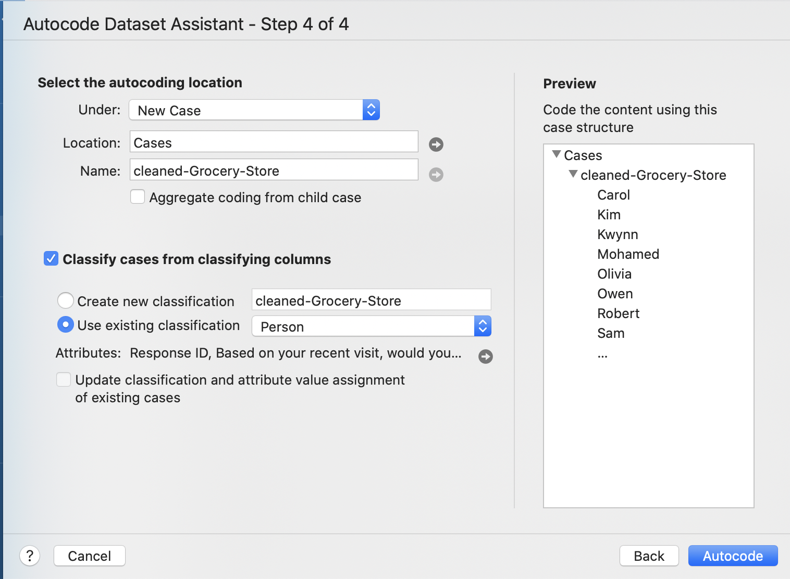

Merge your cases
The autocoding process did not allow us to automatically merge cases from the survey into existing cases created for the reviews, rather a new folder was created in cases called cleaned-Grocery-Store. We will need to complete the following steps to add the new cases (Carol, Kim, Owen, and Robert) to the top level Cases folder, and to merge the duplicate cases (Kwynn, Mohamed, Olivia, Sam, and Shahira).

- Click on Cases > Cases in the Navigation View

Move the new cases to the top level folder
- Select Carol, Kim, Owen, and Robert from the List View
- Drag and drop them onto Cases (the smaller one) in the Navigation View to move them to the top level

Merge the others into their top-level counterparts
- Right-click on Kwynn in the cleaned-Grocery-Store folder > Copy
- Right-click on Kwynn in the top level of cases > merge into selected case > Merge
- Delete Kwynn’s case in the cleaned-Grocery-store folder
- Repeat for the other cases in the cleaned-Grocery-store folder (Mohamed, Olivia, Sam, Shahira)

Examine your Classification Sheet
You will need to review the classification sheet to fix any errors. For example, the survey did not ask about Gender, nor is Reply applicable to those survey respondents that did not write a review.

Open the Classification sheet to review the import:
- Click on Cases > Case Classifications > Person
- Right click on Person > Open
- Click on the Classification Sheet tab
  - Update the Gender and Reply columns for Carol (female, not applicable), Kim (non-binary, not applicable), Owen (male, not-applicable), and Robert (male, not applicable).

Code Open Ended Question
Create a draft code folder for the survey
- Right-click on Codes in the Navigation View > New Folder > call it cleaned-Grocery-Store

Note: we are coding to this section instead of the main coding area, so that we can have a back up list of new codes.

Open your file in the Details View:
- Click on Files > Survey in the Navigation View
- Double-click on cleaned-Grocery-Store in List View to launch it in Details View

Code the text
- Scroll to the open-ended question and highlight the text you want to code
- Click on Coding > Codes > cleaned-Grocery-Store
- Right click > code selection > To new code (or existing code)
  - Provide a name
  - Change the location from Codes to cleaned-Grocery-store using the arrow to the right of Location: Codes
  - Click Done
- Repeat until you have coded all of the cells for the open ended question

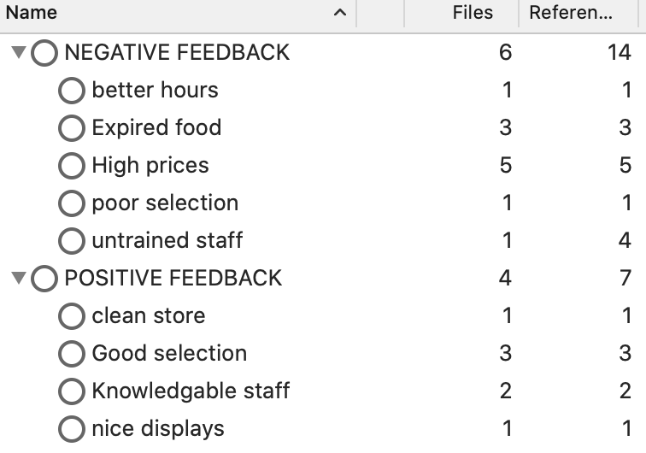
Merge new codes with previous codes
- Click on Coding > Codes > cleaned-Grocery-Store in the Navigation View
- Copy all of the codes in the cleaned-Grocery-Store section
- Right-click on Coding > Codes in the Navigation View > Paste
- Proceed with any sort of merging and hierarchical organisation needed as explained in Part 1 of the workshop.

Focus Groups

Import data set
- Right click on Files in the Navigation View > New folder > Name it Focus Group> Ok
- Click on Import tab > Files > Documents and navigate to focus_group_transcript.docx > Import
- Click Done

Autocode text for Speaker Name
Focus group transcripts or any other document that has multiple speakers can be autocoded so that the text pertaining to each speaker gets coded to their case.

- Click on Home > Autocode > by Speaker
- In the Autocode by Speaker dialogue box
  - Type in the first speaker’s name > Enter
  - Create cases in: Cases
  - Choose Person in the drop down menu for What would you like to classify your cases as
  - Click on the plus sign to add a new speaker
  - Continue until all of the speakers have been named
Note that each time you add a speaker, the text block changes to show each speaker’s text block
  - Click Autocode

Review the Cases table
- Click on Cases in the Navigation View to see the Cases table (you might have to x out any of the tabs in the Details View.
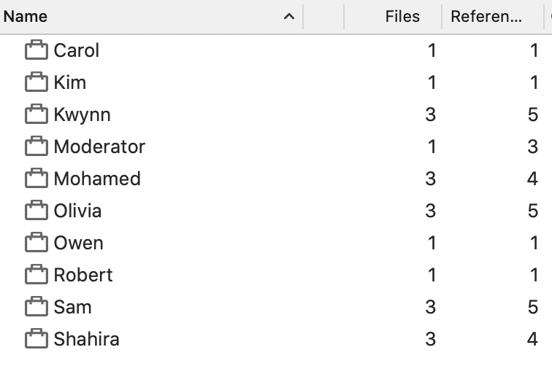

Code transcript (Optional)
- Open the transcript in Details View
- Create a new codes folder called focus_group to keep a separate set of codes
- Code the text to new or existing codes.
- Copy and paste to integrate them into the top level codes.

Visualisations
NVivo provides lots of options to visualise trends and patterns in your data. Take some time to review the videos below to see what you can do.

Hierarchy chart
Hierarchy charts are great for seeing which codes are more heavily used than others.
https://youtu.be/rObahpTnIbw
Create a chart showing the breakdown of positive and negative feedback:

- Click on Explore
- Click on Hierarchy Chart
  - Visualize: Coding for Codes
  - Compare > Selected Items > Only the parent and child codes for Negative and Positive feedback
  - Size by: coding references

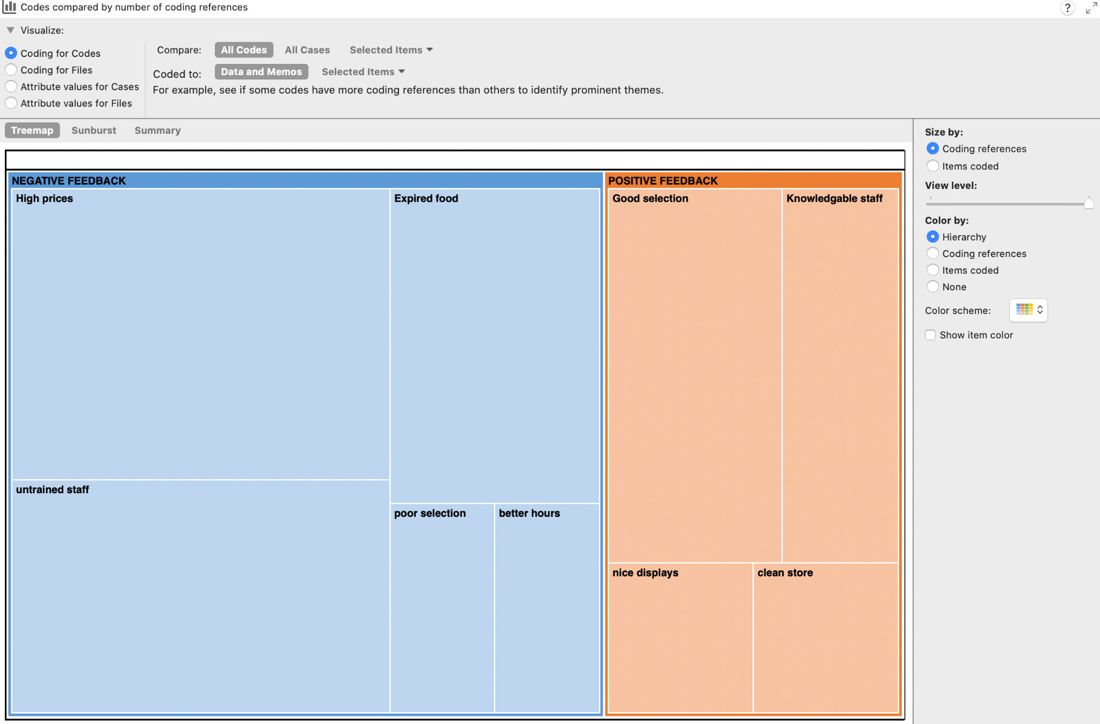

Chart coding by attribute value
Breaks down coding to a thematic code by an attribute value https://youtu.be/NKvcNGUmbxY
Create a chart that shows how the gender make up of those whose comments were coded to High Prices
- Click on Codes in the Navigation View to show the codes in the List View
- Right click on high prices > Visualize > Chart selected code
  - Data: attributes > select gender from the drop down menu
  - Format: you can adjust as you like
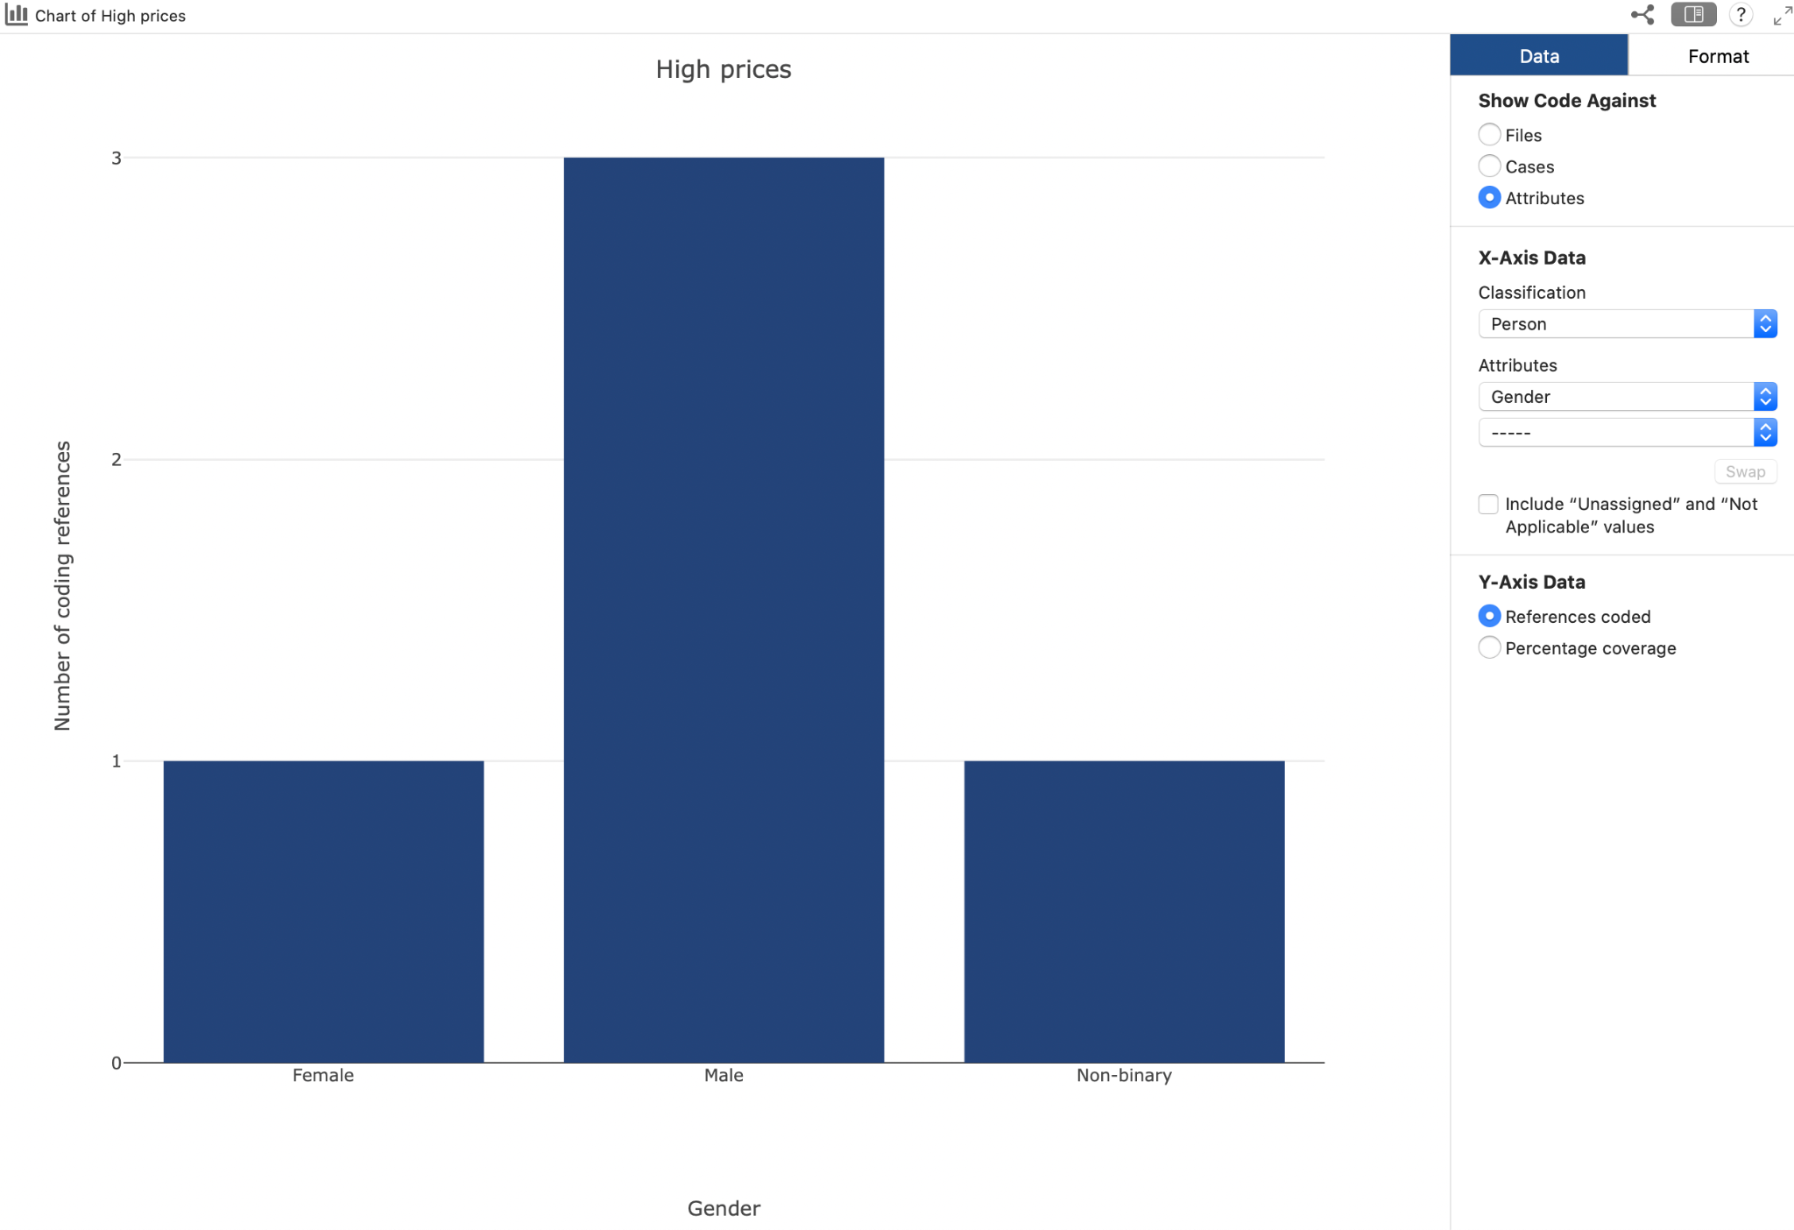

Comparison diagrams
Compare files, codes or cases https://youtu.be/fybS5WMAGAY
You would like to compare the codes “High prices” and “untrained staff”. The comparison diagram will indicate files and cases coded to these codes.

- Click on Explore > Diagrams > Compare Codes
- Use your mouse and cmd key to select the 2 codes > Select
  - You can adjust the settings by checking or unchecking
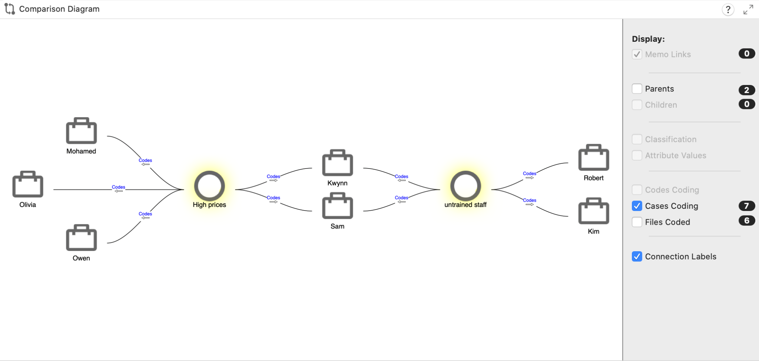

Explore Diagrams Codes and Files
Allow you to explore how connections among files, codes and cases which vary by the focus item https://youtu.be/cPavz8YnTb0

Explore “high prices”
- Click on Codes in the Navigation View to show the codes in the List View
- Click on “High prices” in List View
- Click on Diagrams > Explore diagram
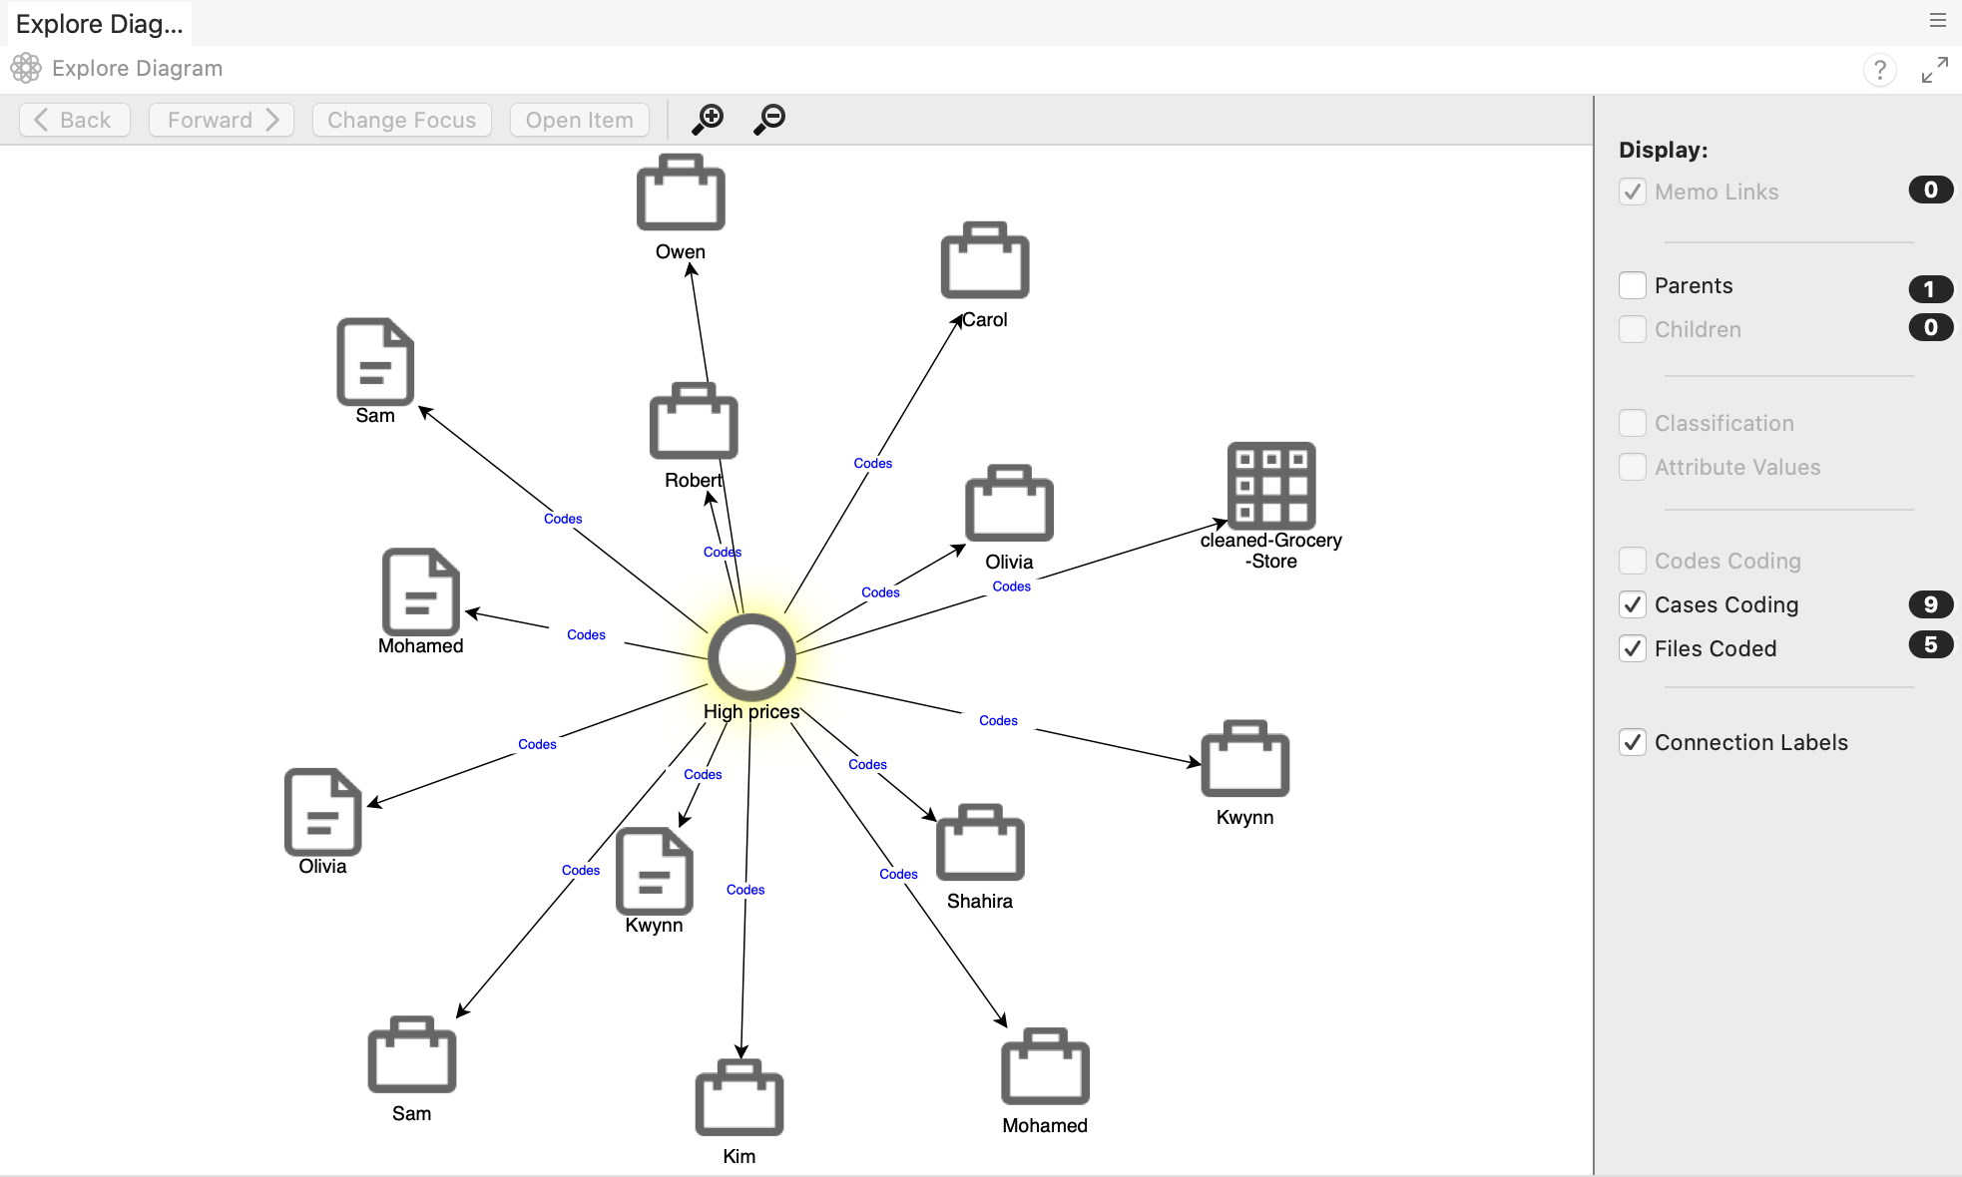
- To change focus, right click on another item in the diagram > change focus

Word Clouds
Quickly visualise frequently used words https://youtu.be/uYJdkrkpmIA

Create a word cloud of the content coded to High prices:
- Click on Explore > Word Frequency
  - Click on Selected items > codes > only check High prices > Select
  - Run Query.
- Select Word Cloud
